System Design

Designing a system for fracture classification and doctor's suggestion using deep learning and NLP would require several components to be designed and integrated.

**Data collection and preparation:**

Collect a large dataset of X-ray images and associated reports that have been labeled with fracture types and doctor's suggestions. The data should be properly cleaned and pre-processed before being used for training and testing.

**Image processing and feature extraction:**

Use image processing techniques to preprocess the X-ray images and extract relevant features that can be used for classification. This can include edge detection, segmentation, and feature extraction using deep learning methods such as convolutional neural networks (CNNs).

**Fracture classification:**

Train a CNN model on the preprocessed X-ray images to classify them into different fracture types. The CNN model should be designed with appropriate architecture, activation functions, and optimization techniques.

**NLP processing:**

Use NLP techniques to preprocess the doctor's suggestions from the associated reports. This can include text cleaning, tokenization, and stemming. Then use deep learning models such as recurrent neural networks (RNNs) or transformers to generate embeddings and extract relevant features from the text.

**Doctor's suggestion generation:**

Train a model on the extracted features to generate doctor's suggestions based on the fracture type identified from the X-ray image. The model can be a combination of RNNs and transformers, and can be designed using various architectures such as encoder-decoder models or transformer-based models.

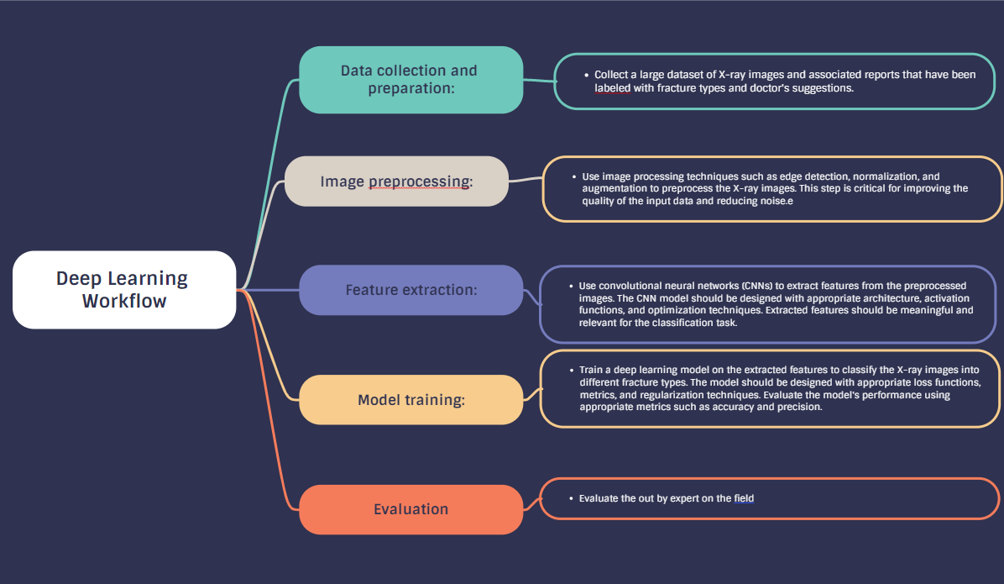**System Design For Deep Learning:**

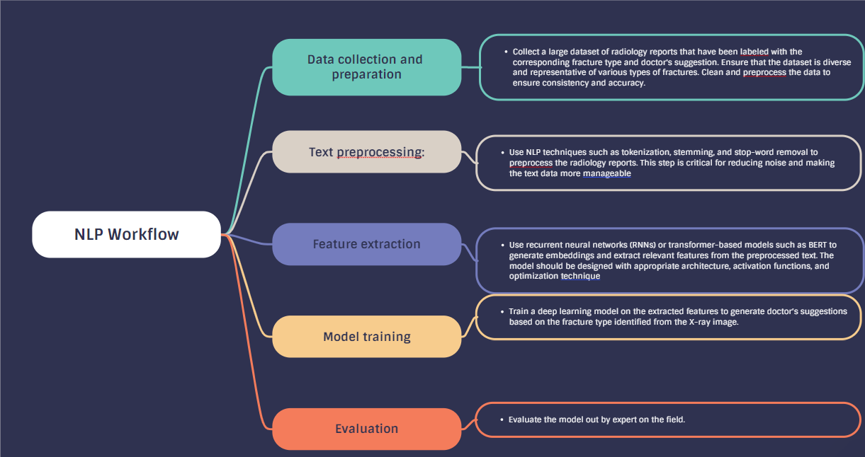**System Design For NLP:**